|  |  |  |
| --- | --- | --- |
| **LAB101 Assignment** | **Type:** | **Long Assignment** |
| **Code:** | **C.L.P0004** |
| **LOC:** | **335** |
| **Slot(s):** | **5** |

**Title**

Quiz Bowl.

**Background Context**

Quiz bowl is a game in which two teams compete head-to-head to answer questions from all areas of knowledge including history, literature, science, fine arts, current events, sports, and popular culture..

**Program Specifications**

Your high school quiz bowl team has been losing its edge and needs to find a method to improve. Knowing that you are a savvy programmer, your coach asks you to write a program that the team members can use to hone their skills. Quiz Bowl questions come in three varieties:

1. True/False
2. Multiple Choice (variable number of choices)
3. Short Answer (all answers are a single word).

Your program will be a training program for a single individual. Initially, your program will ask the user to enter their first and last name, followed by the name of the file storing the questions and answers for his/her training session. (The format of this file is discussed on the following page of this program description.) Then, your program should ask the user how many questions they would like for practice. (Your program should prompt the user with the maximum allowed, based on how many questions were in the input file they entered.) Make sure you gracefully handle a situation where the user doesn't enter a valid value or token. Then, your program should prompt the user with the number of random questions from this database that they requested. (Do NOT ask duplicate questions!) The user will have two options:

1. Answer the question
2. Skip the question

If the user skips the question, they neither gain nor lose points.

If the user answers the question correctly, they gain the number points at which the question is valued. If they answer incorrectly, they lose the same number of points.

When answering, to indicate that the user wants to skip the question, they MUST answer "SKIP" (It is guaranteed that no question will have as its correct answer, "SKIP".)

***Function details:***

1. Your program must input data from file txt.
2. Your program must error check the response to the number of questions the user wants, checking for both the type of information entered as well as whether or not the value is valid.
3. Your program must keep score and prompt the user with how many points they earned or lost after each question, as well as what their total score is at the end of the game.

***Expectation of User interface:***

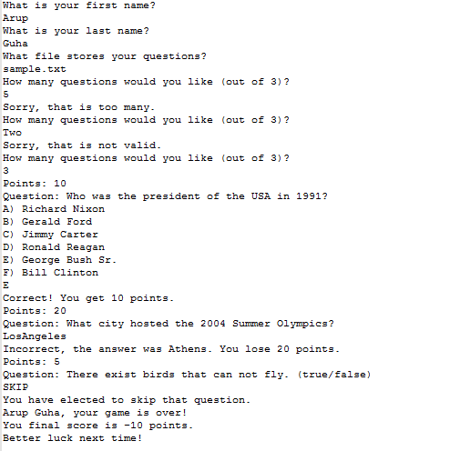

**Guidelines**

The first line of a question database file will contain a single integer n, the number of questions in the file. The following n sets of data contain information about each question.

The first line in each set of data will contain a string that indicates the type of question followed by a positive integer indicating the point value of the question. The string is guaranteed to be one of the three following: "TF", "MC", or "SA".

The second line in each set of data will contain a string that is the question. This string will definitely contain spaces – you must read in the whole line in order to read in the whole question.

If the question is a true/false question, then the third line of the data set will contain either contain the string "true" or the string "false", depending on the answer to the question.

If the question is a short answer question, then the third line of the data set will contain a single string without spaces indicating the answer to the question.

If the question is a multiple choice question, then the third line of the data set will contain a single positive integer, k, less than 10, indicating the number of choices for the question.

The following k lines will contain each of the possible answers. These answers could have spaces in them – you have to read in the whole line. (These lines will correspond to choices A, B, C, etc.)

The last line of a multiple choice question will contain a string storing the correct answer. This string will be a capital letter corresponding to the correct answer choice. (Since there are at most 9 choices, this will always be either "A", "B", "C", "D", "E", "F", "G", "H", or "I".)

**Sample Input File (sample.txt)**

*3*

*TF 5*

*There exist birds that can not fly. (true/false)*

*true*

*MC 10*

*Who was the president of the USA in 1991?*

*6*

*Richard Nixon*

*Gerald Ford*

*Jimmy Carter*

*Ronald Reagan*

*George Bush Sr.*

*Bill Clinton*

*E*

*SA 20*

*What city hosted the 2004 Summer Olympics?*

*Athens*